COMBINATIONS
Pearson Edexcel - Tuesday 21 May 2019 - Paper 1 (Non-Calculator) Higher Tier
1.
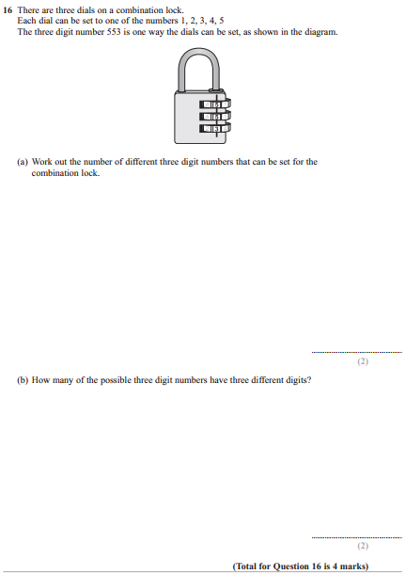

Pearson Edexcel - Thursday 8 November 2018 - Paper 2 (Calculator) Higher Tier
2.
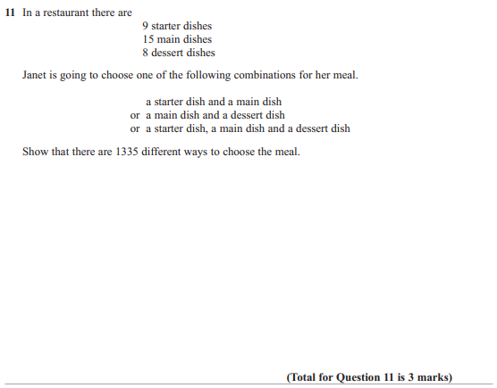
Pearson Edexcel - Tuesday 13 June 2017 - Paper 3 (Calculator) Higher Tier
3.
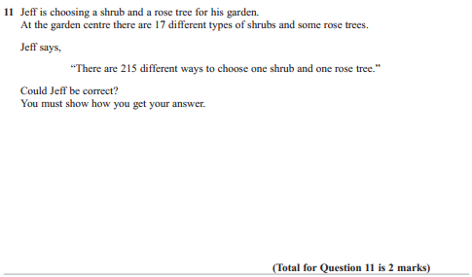

Pearson Edexcel - Specimen Papers Set 2 - Paper 2 (Calculator) Higher Tier
4.
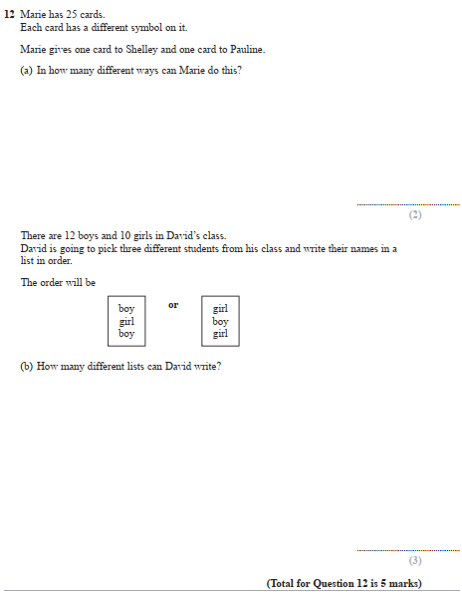
Pearson Edexcel - Specimen Papers Set 1 - Paper 3 (Calculator) Higher Tier
5.
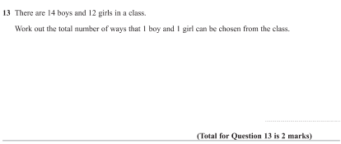
Pearson Edexcel - Sample Paper 3 - (Calculator) Higher Tier
6.
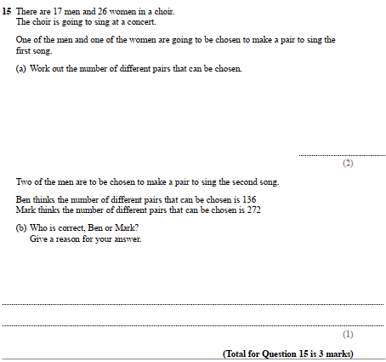

Pearson Edexcel - Thursday 26 May 2016 - Paper 1 (Non-Calculator) Higher Tier
7.
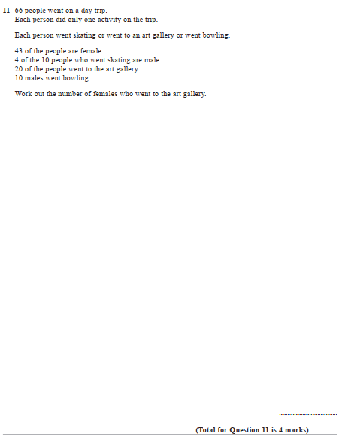

Pearson Edexcel - Wednesday 4 November 2015 - Paper 1 (Non-Calculator) Higher Tier
8.
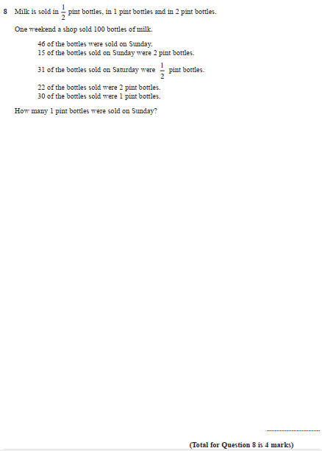

Pearson Edexcel - Monday 9 June 2014 - Paper 1 (Non-Calculator) Higher Tier
9.
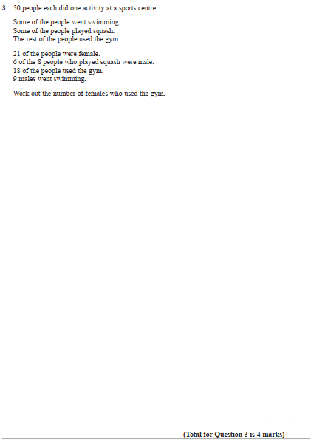
OCR GSCE – Tuesday 5 November 2019 – Paper 4 (Calculator) Higher Tier
10.
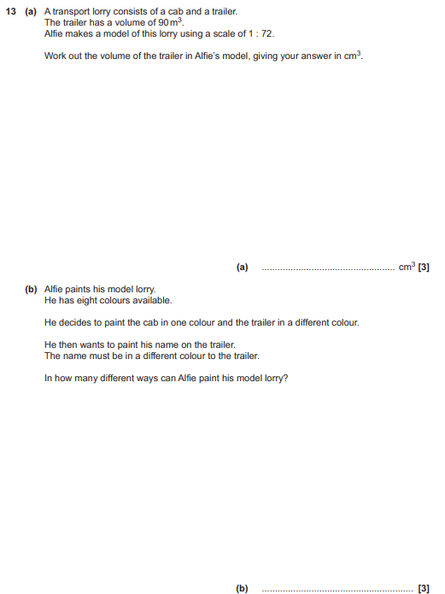

OCR GSCE – Monday 11 November 2019 – Paper 6 (Calculator) Higher Tier
11.
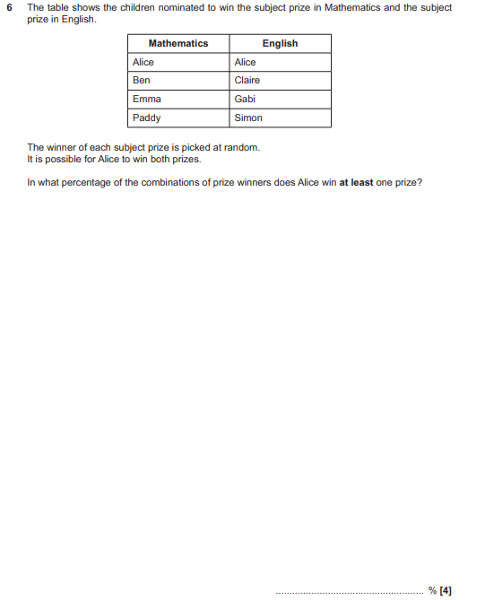

OCR GSCE – Tuesday 2 November 2017 – Paper 4 (Calculator) Higher Tier
12.
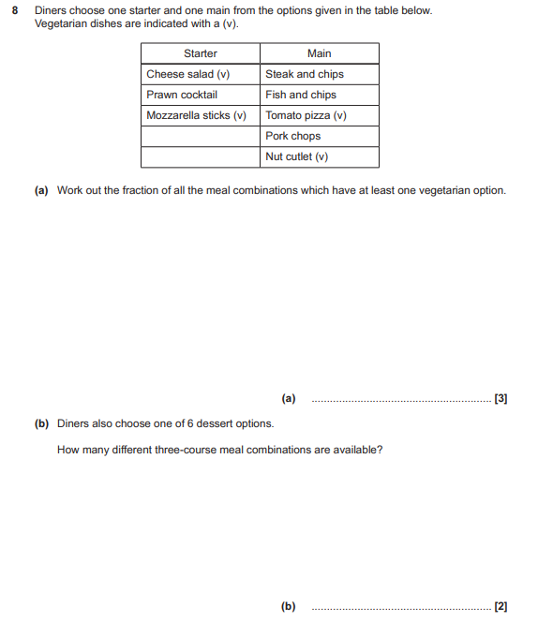

OCR GSCE – Thursday 8 June 2017 – Paper 5 (Non - Calculator) Higher Tier
13.
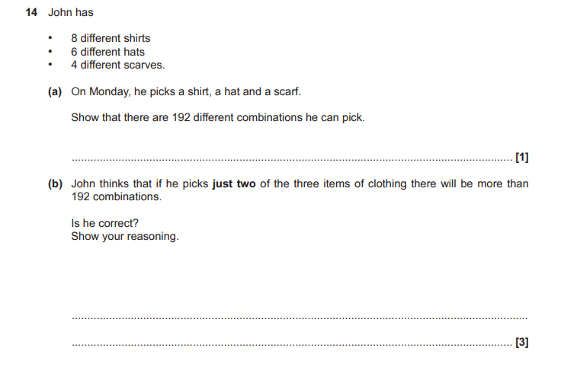
OCR GSCE – Sample Papers – Paper 4 (Calculator) Higher Tier
14.
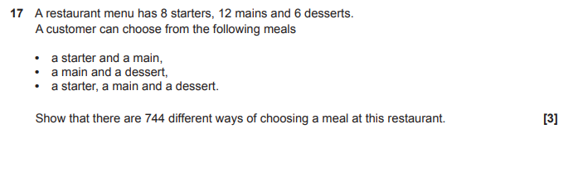

AQA GSCE – Thursday 4 June 2020 – Paper 2 (Calculator) Higher Tier
15.
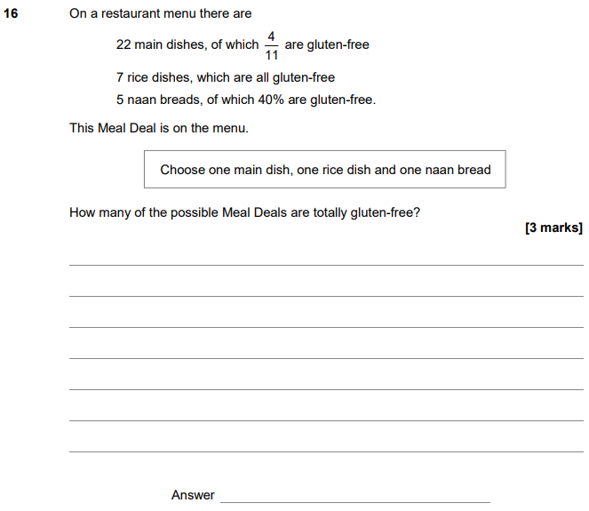

AQA GSCE – Thursday 2 November 2017 – Paper 1 (Non - Calculator) Higher Tier
16.
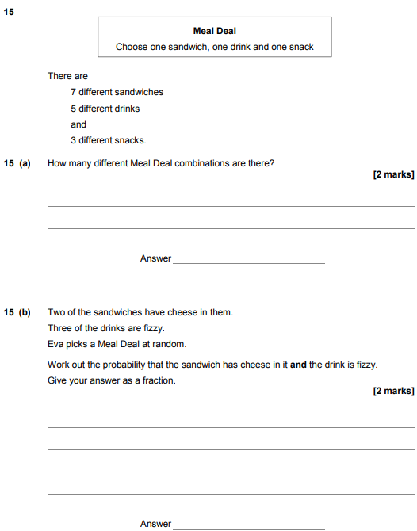

AQA GSCE – Sample Paper 2 (Calculator) Higher Tier
17.
